**EUROfusion TBM secondees take up duties at F4E Cadarache**

[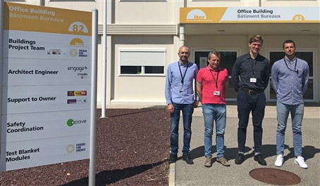](https://f4e.europa.eu/Downloads/News/07_TBM_image_web-160720191200-Large.jpg)

EUROfusion secondees A. Pitigoi (Empresarios Agrupados, as Third Party of CIEMAT), A. Aiello (ENEA), A. Lukenskas (CCFE) & A. Tallarigo (CCFE).

F4E's Test Blanket Modules (TBM) Team welcomes four new [EUROfusion](https://www.euro-fusion.org/) secondees who join the work in developing the TBM programme at F4E Cadarache.

In 2016, F4E's focus on Straight Road to First Plasma (SR2FP) meant that systems necessary to achieve First Plasma were prioritised. Accordingly, some of the F4E TBM programme's resources were temporarily reallocated as the TBM Systems are foreseen to be installed later during ITER's third phase assembly in 2030-31.

A Working Group consisting of F4E and EUROfusion explored how to make the most of European resources and a new collaborative scheme was developed in order to jointly execute the TBM programme between F4E and EUROfusion. In DEMO, the tritium self-sufficiency is essential which means that the amount of tritium consumed in a given period of time must be generated in the machine itself. In a tokamak fusion reactor this "in situ" tritium generation takes place thanks to the fusion neutrons leaving the plasma and interacting with a specific element – lithium – contained in the so called "breeding blanket", a complex structure surrounding the plasma chamber. Although the breeding blanket will not be present in ITER because tritium consumption will be much lower and can be covered by existing world's resource, ITER will provide a unique opportunity to test mock-ups of different possible breeding blankets concepts and connected circuits, called Test Blanket Systems (TBS), in a real fusion environment. Within these TBS, viable technologies for ensuring the expected tritium generation and recovery will be explored and validated, with the final aim to demonstrate the tritium self-sufficiency of the parent DEMO breeding blanket concept.

While F4E has been developing since 2008 only helium-cooled TBS for testing in ITER, the EUROfusion Consortium was still considering various coolant types for Breeding Blankets in DEMO. An international review panel studied the programmes of both F4E and EUROfusion and came to the conclusion that one of the two helium-cooled TBS developed so far by F4E (HCLL, Helium-Cooled Lead-Lithium) should be replaced by a water-cooled system (WCLL, Water-Cooled Lead-Lithium), which is a technology offering potentially the fastest development path to DEMO. This revision to the scope of the F4E's TBM Team allowed fora full programmatic alignment with EUROfusion, whilst offering coverage of a larger set of technologies. This change also allowed for new collaboration schemes: EUROfusion would make use of its specialised R&D resources to support TBS development and would benefit from the return of F4E's experience in engineering. In addition, to make this partnership even tighter, certain EUROfusion European Fusion Laboratories (EFLs) would send engineers to join the F4E's TBM Project Team. These seconded engineers have now arrived and taken up their duties at F4E Cadarache. Seconded from [ENEA](http://www.enea.it/it), [CCFE](http://www.ccfe.ac.uk/) and [Empresarios Agrupados](https://www.empresariosagrupados.es/?lang=en)(as third party of [CIEMAT](http://www.ciemat.es/)), Alberto Tallarigo (CCFE), Antonio Aiello (ENEA), Adomas Lukenskas (CCFE) and Adrian-Eugen Pitigoi (Empresarios Agrupados), will be dealing with TBM technical and project management.

"Together with EUROfusion, we have demonstrated that we are able to rationalise the use of personnel and budget resources for fusion research", says F4E's TBM Programme Manager, Yves Poitevin. "This arrangement also has positive long-term consequences: by hosting staff from EFLs at F4E Cadarache we also support and prepare them for the best exploitation of results from the ITER machine – something which will benefit future European fusion research at large".